Bend Climate Graph - Oregon Climate Chart
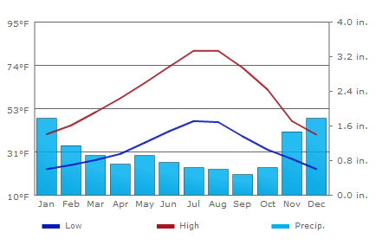
Source: http://www.usclimatedata.com/climate.php?location=USOR0031
Accessed 10-4-2010

